

**FPT ACADEMY INTERNATIONAL**

**FPT – APTECH COMPUTER EDUCATION**

TRAVEL ToVN

eProject Report Semester 4

|  |  |  |
| --- | --- | --- |
| **Supervisor** | Ngo Phuoc Nguyen | |
| **Batch** | T1.1807.M0 | |
| **Group** | 5 | |
| **Serial No.** | **Student Name** | **Enrollment Number** |
| 1. | Dang Vu Thang | Student1119862 |
| 2. | Nguyen Huu Phuc | Student1114449 |
| 3. | Ta Van Vu | Student1114447 |
| 4. | Tran Duc Truong Giang | Student1114461 |

**May – 2020**

**This is to certify that**

**Mr./Ms.:**

DANG VU THANG

NGUYEN HUU PHUC

TA VAN VU

TRAN DUC TRUONG GIANG

**Has successful design & developed:** eProject: TRAVEL ToVN

**Submitted by:** DANG VU THANG

**Date of issue:** May – 2020

**Authorized Signature:**

**_______________________________________**

TABLE OF CONTENTS:

**ACKNOWLEDGEMENT** 5

**REVIEW 1** 6

**INTRODUCTION** 7

**PROBLEM DEFINITION** 8

**CUSTOMER REQUIREMENT SPECIFICATION** 9

**SCOPE OF WORK** 11

**SYSTEM REQUIREMENT SPECIFICATION** 12

**Hardware** 12

Web Server 12

Client 12

**Software:** 12

Web Server 12

Client 12

**TASK SHEET REVIEW 1** 14

**REVIEW 2** 15

**DATA FLOW DIAGRAM** 16

Architecture and Design of the System: 16

I. Context Level Diagram: 16

II. First Level DFD: 17

III. DFD for Booking Cycle: 19

**Flowchart** 20

I. Login Function: (Users) 20

II. Signup Function for customers: (Users) 21

III. Searching data function: 22

IV. View data function: 23

V. Insert data function: (Admin) 24

VI. Login Function: (Admin) 25

**ENTITY RELATIONSHIP DIAGRAM** 26

**TABLE DESIGN** 27

I. Table Users: 27

II. Table Roles: 27

III. Table Tours: 28

IV. Table TourTypes: 28

V. Table TourLocations: 29

VI. Table TourImages: 29

VII. Table ReviewTours: 29

VIII. Table ReviewGuides: 30

IX. Table Locations: 30

X. Table Guides: 31

XI. Table Bookings: 31

XII. Table AuthenticationProviders: 31

**TASK SHEET REVIEW 2** 32

# **ACKNOWLEDGEMENT**

Our group would like to devote this chapter to express our deepest appreciation to all those who offered us valuable assistance during in carrying out this eProject.

First and foremost, we owe a debt of gratitude to our dedicated instructor, Mr. Ngo Phuoc Nguyen, whose suggestions and encouragement helped us to overcome not only technological challenges but also psychological tension. Without her, our work could not have been completed successfully.

Secondly, we highly appreciate the eProject Team at the Head Office which has provided us a golden opportunity to apply what we learned into practice. We are certain that the experiences we gained from this project will facilitate our future career greatly. Besides, we would also like to express my gratitude to all the staff members of my center for not only providing me with the opportunity to work with them on this project, but also for their support and encouragement throughout the process.

Finally, we wish to say a personal thank you to all our dear classmates and team members who are always willing to support us openly and enthusiastically.

# **REVIEW 1**

# **INTRODUCTION**

During the period of information technology and computer development people can search and find anything at home vie internet connection and use online services. Therefore, we are developing a service “Book any tours, anywhere online” named TRAVEL ToVN.

TRAVEL ToVN is a group of people who wants to develop an online site where the user who is too busy to think of where they can travel. It will provide its user the following features.

**For TRAVEL ToVN’s customers:**

* Provide an interactive GUI, on the World Wide Web for the user.
* User can search any tours and the web will show them the tour they want to refers before they book.
* User can review the tour that they traveled and for the guides, too.
* User can see booking history.
* User can chat with Supporters for any question they have about Website or about their tours.
* User can login with Facebook or Gmail.

# **PROBLEM DEFINITION**

After reading the project specifications of TRAVEL ToVN, our group has discussed about what should to be done to fulfil their requirements properly. We came to conclusion that in order to achieve the best result, we should deal with following queries:

**From the view point of users**

1. How can the customer book the tours?
2. How can the customer find the tours they want?
3. How does the customer keep track their history booking that they booked?
4. How can the customers review the tours they joined or the guides they want to review?
5. How can the customer login with their Facebook or Gmail?

**From the view point of the Administrator**

1. How can the admin create new tour?
2. How can the admin read, update tour’s or guide’s information?
3. How can the admin see bookings history?
4. How can the admin send e-mail directly from the system to users in order to inform verified the booking tour?
5. How can the admin manage location?
6. Will the systems be able to check the validity of users’ information before saving into the database?

**CUSTOMER REQUIREMENT SPECIFICATION**

**Client:** TRAVEL ToVN.

**Business/Project Objective:** The project is to design a service online for booking tour and recommend tours.

**Input to the system:**

**TRAVEL ToVN’s administrators need to provide:**

* + Information required in order to create account to access to the admin system.
  + Information about tours and guides going to be shown on the website.

**TRAVEL ToVN’s website visitors need to provide:**

* + Personal information to create an account.

**Output from the system:**

**TRAVEL ToVN’s administrators will be able to:**

* + Login/Logout to the admin system.
  + Manage (view, add, search, update, and delete) tours.
  + Manage (view, add, search, update, and delete) guides.
  + Manage (view, search, active/deactive) registered customers.
  + Manage (view, search) review Tour and review Guide.
  + Manage (view) booking history.
  + Manage (view, add, search, update, and delete) location.

**TRAVEL TOVN’s guide will be able to:**

* View, edit their information.
* View tours that they have guided.
* View review about them.
* View their rating.

**TRAVEL TOVN’s website visitors will be able to:**

* If visitors are guests:
* Search tour or location they want to go.
* View tours’ and guides’ information
* View review about tours and guides
* If visitors are registered members:
  + Login or logout.
  + Book tour, view tours, location, guides.
  + View booking history.
  + Search tours and location.
  + Review tour and guide.
  + Change personal information.

# **SCOPE OF WORK**

The application should perform the following functions:

**Login:**

* There are 3 types of account in the application (“admin”, “guide” and “user”). Administrator will login as “admin”, Guide will login as “guide” and Customer will login as “user”.
* Three accounts must be registered and login for using the functionality of the application.
* For “admin”: can view the customer id name, add new/modify.
* For “guide”: can view/modify their info, change their password.
* For “user”: can change the profile, change their password, register new account, or login with google or facebook.

**Booking tour:**

* When user choose a tour and a window will appear for them to book tour of their choice.

**Review Tour or Guide:**

* When user view tour’s or guide’s information, they can review tour or guide in the box below the tour’s or guide’s information.
* And they can only review when they joined tour and tour ended, review guides, too.

**Database**

* The information about tours, guides, bookings, reviews, locations, will be stored in the database, and users can view on the Web.

**Security:**

* The user password will be encrypted and stored in the database.

# **SYSTEM REQUIREMENT SPECIFICATION**

## **Hardware**

### Web Server

|  |  |
| --- | --- |
| Processor | Intel Core i5 or higher. |
| Memory | 4 GB RAM or greater. |
| Modem/ADSL | Connecting to internet 24/24 |

### Client

|  |  |
| --- | --- |
| Processor | Intel Core i3 or higher. |
| Memory | 2 GB RAM or greater. |
| Monitor | Super VGA (1024x768) or higher resolution |
| Modem/ADSL | Connecting to internet |

## **Software:**

### Web Server

|  |  |
| --- | --- |
| Operation System | Windows 7 or higher |
| Browser | Chrome version 35 or Microsoft Edge. |
| Database | PostgreSQL 12 |
| Software | Internet Information Service |
| JAVA |
| NetBean |
| GlassFish |

### Client

|  |  |
| --- | --- |
| Operation System | Windows 7 or higher |
| Browser | Chrome version 35 or Microsoft Edge. |

**2.1 Development software**

* + Microsoft Windows 10
  + NetBean 8.2
  + PostgreSQL 12
  + Google Chrome or Microsoft Edge
  + Heroku
  + Git
  + DBeaver
  + Visual Studio Code
  + Eclipse
  + Postman

**2.2 Technology**

* JavaEE
* React
* Firebase
* Javascript
* jQuery
* Bootstrap
* Ajax
* Java Springboot, SpringWeb, Thymeleaf.

# **TASK SHEET REVIEW 1**

|  |  |  |  |  |  |  |  |
| --- | --- | --- | --- | --- | --- | --- | --- |
| **Project Ref. No.:**  **TRAVEL ToVN** | | **Project Title:** | **Activity Plan Prepared By:** | **Date of Preparation of Activity Plan:** | | | |
| **Sr.No.** | **Task** | **Actual Start Date** | **Actual Days** | **Team Mate Names** | **Status** |
| 1 | Introduction and Problem Definition | TRAVEL ToVN | Dang Vu Thang | 22/05/2020 | 1 | - Dang Vu Thang  - Nguyen Huu Phuc  -Ta Van Vu  -Tran Duc Truong Giang | 100% |
| 2 | Customer Requirement Specification (CRS) | 22/05/2020 | 1 | 100% |
| 3 | Functional Requirement | 22/05/2020 | 1 | 100% |
| 4 | System Requirement Specification |

# **REVIEW 2**

# **DATA FLOW DIAGRAM**

## Architecture and Design of the System:

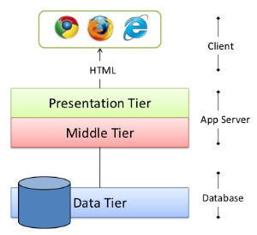

## Context Level Diagram:

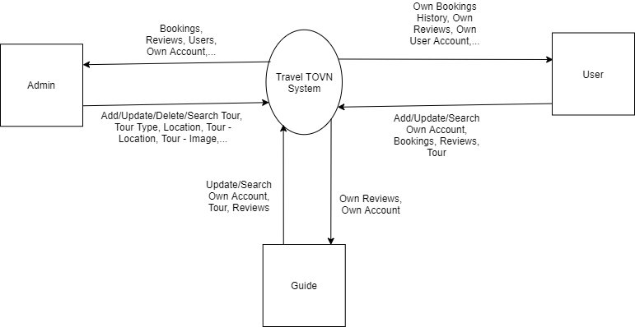

## First Level DFD:

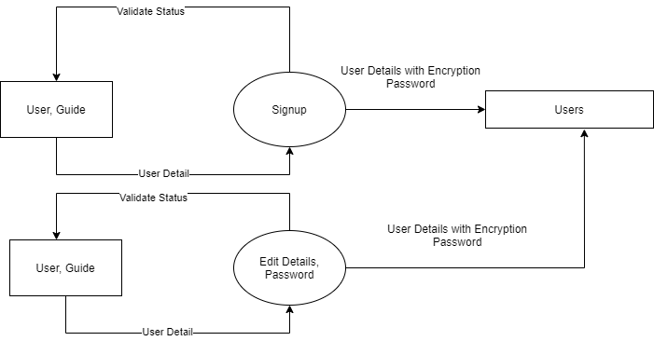

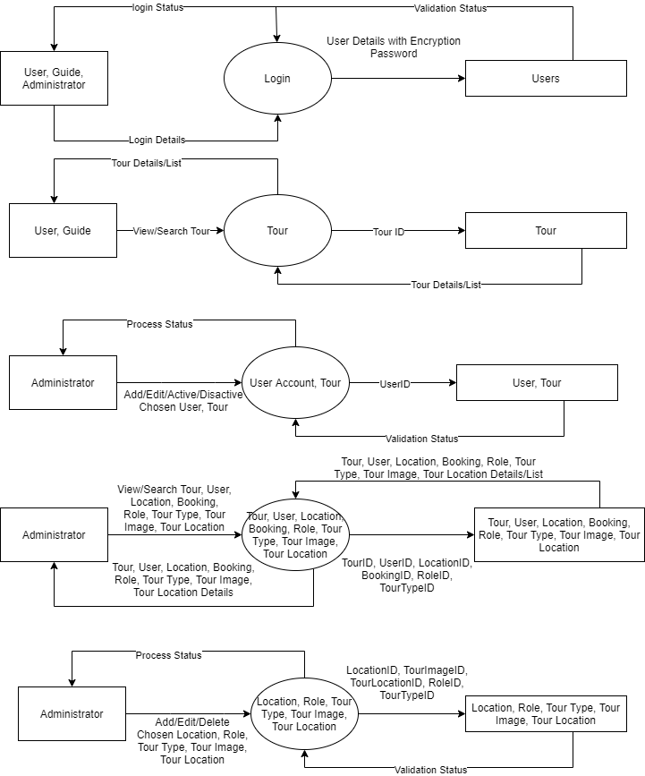

## DFD for Booking Cycle:

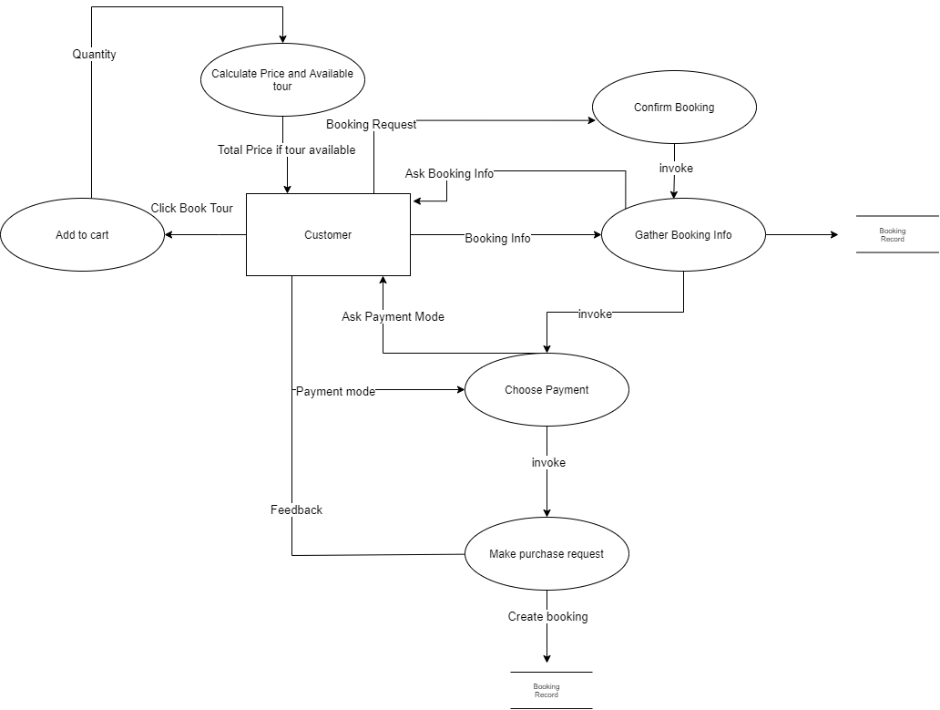

# **Flowchart**

## Login Function: (Users)

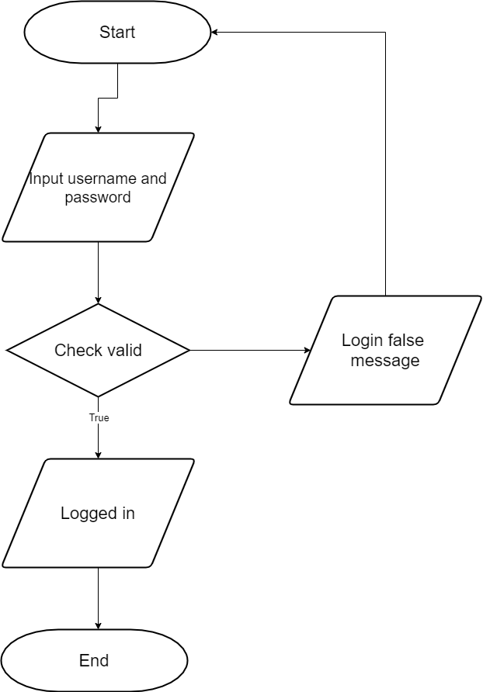

## Signup Function for customers: (Users)

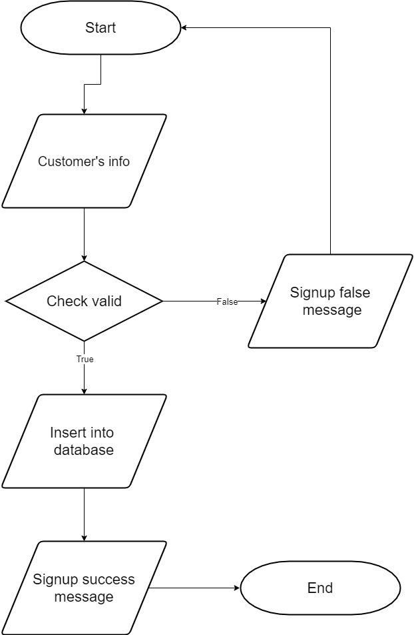

### Searching data function:

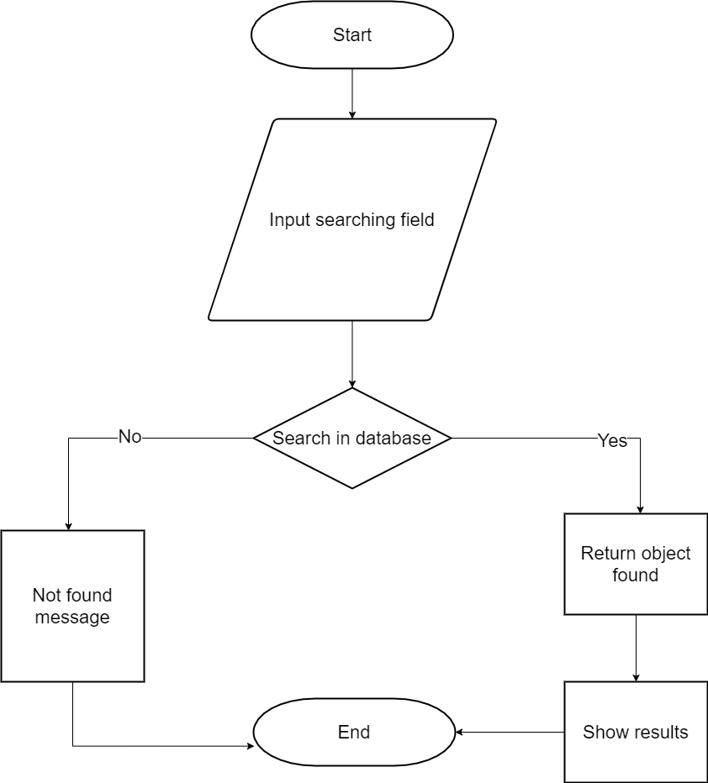

## View data function:

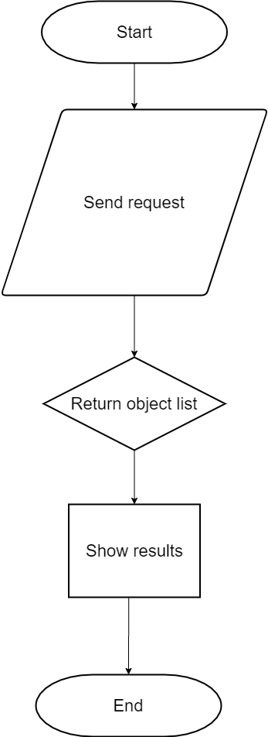

## Insert data function: (Admin)

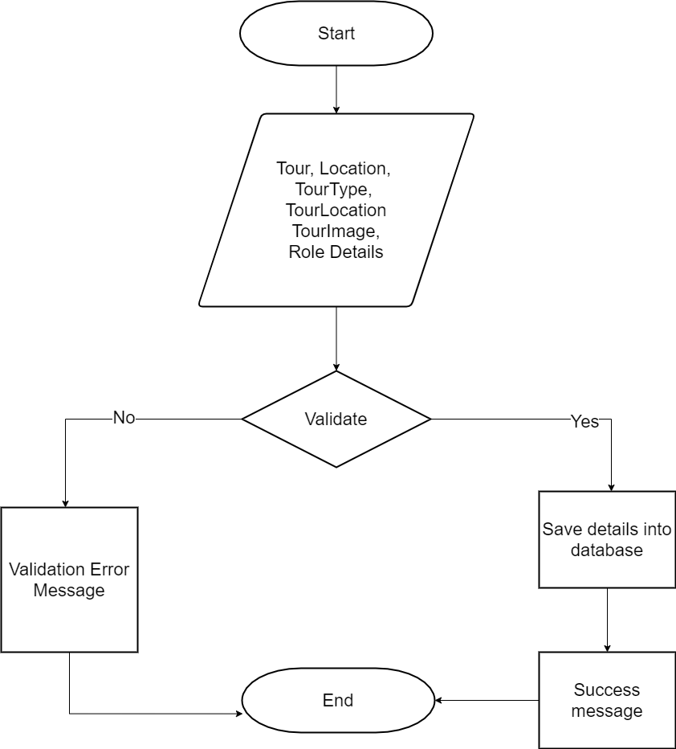

## Login Function: (Admin)

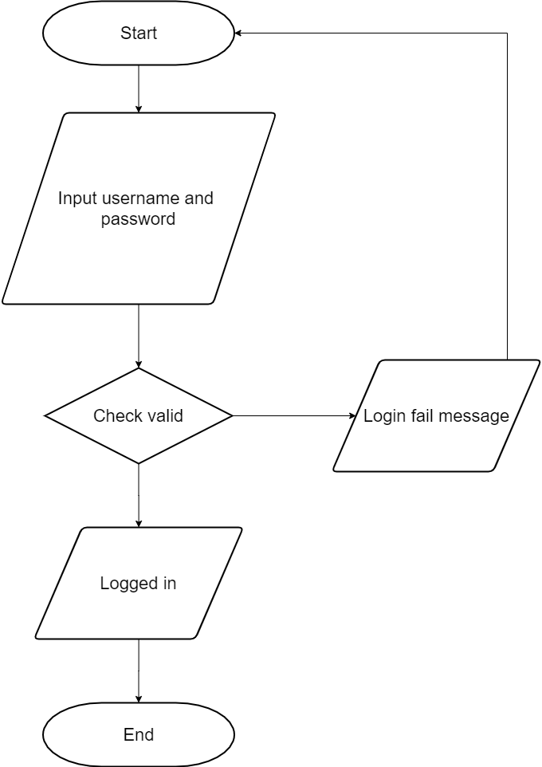

# **ENTITY RELATIONSHIP DIAGRAM**

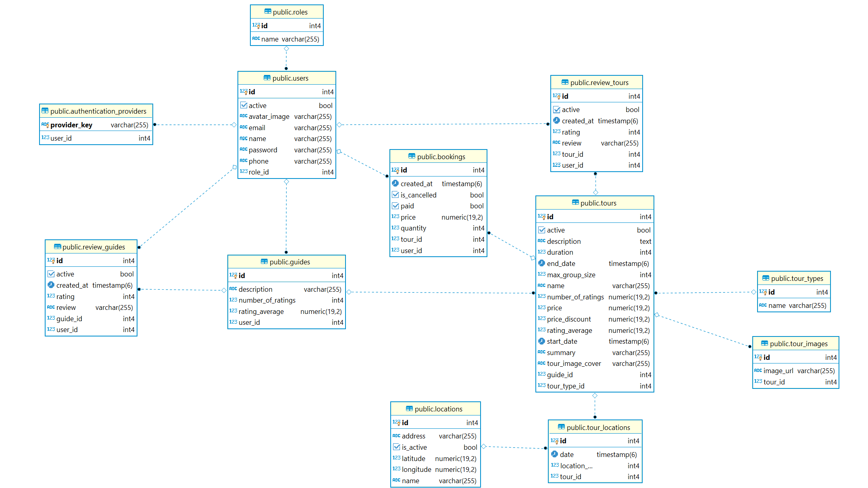

# **TABLE DESIGN**

## Table Users:

|  |  |  |  |  |  |  |
| --- | --- | --- | --- | --- | --- | --- |
| **Users** | | | | | | |
| **Field Name** | **Data Type** | **Null** | **Default Value** | **Key** | **Table-Field-Ref** | **Description** |
| ID | bigint | No |  | PK | Identity | Stores user id |
| Email | Character varying (255) | No |  |  |  | Stores user email |
| Name | Character varying (255) | No |  |  |  | Stores name of user |
| Password | Character varying (255) | No |  |  |  | Stores user password |
| Phone | Character varying (255) | No |  |  |  | Stores user phone number |
| Active | boolean | No | true |  |  | Stores active status of user |
| avatarImage | Character varying (255) | No |  |  |  | Stores avatar for the user |
| Role_id |  | No |  | FK |  | Stores user role |
|  |  |  |  |  |  |  |

## Table Roles:

|  |  |  |  |  |  |  |
| --- | --- | --- | --- | --- | --- | --- |
| **Roles** | | | | | | |
| **Field Name** | **Data Type** | **Null** | **Default Value** | **Key** | **Table-Field-Ref** | **Description** |
| ID | bigint | No |  | PK | Identity | Stores role id |
| Name | Character varying (255) | No |  |  |  | Stores role name |

## Table Tours:

|  |  |  |  |  |  |  |
| --- | --- | --- | --- | --- | --- | --- |
| **Tours** | | | | | | |
| **Field Name** | **Data Type** | **Null** | **Default Value** | **Key** | **Table-Field-Ref** | **Description** |
| ID | bigint | No |  | PK | Identity | Stores tour id |
| Name | Character varying (255) | No |  |  |  | Stores name of tour |
| Start_date | timestamp | No |  |  |  | Stores tour start date |
| End_date | timestamp | No |  |  |  | Stores tour end date |
| Description | text | No |  |  |  | Stores tour description |
| summary | text | No |  |  |  | Stores tour summary |
| duration | integer | No |  |  |  | Stores tour duration |
| Max_group_size | integer | No |  |  |  | Stores tour max size |
| price | Numeric  (19,2) | No |  |  |  | Stores tour price |
| Price_discount | Numeric  (19,2) | No |  |  |  | Stores tour discount |
| Number_of_ratings | Numeric  (19,2) | No |  |  |  | Stores number of ratings of tour |
| Rating_average | Numeric  (19,2) | No |  |  |  | Stores tour rating average |
| Tour_image_cover | Character varying (255) | No |  |  |  | Stores tour image cover |
| Guide_id | bigint | No |  | FK |  | Stores guide id of tour |
| Tour_type_id | bigint | No |  | FK |  | Stores type id of tour |

## Table TourTypes:

|  |  |  |  |  |  |  |
| --- | --- | --- | --- | --- | --- | --- |
| **TourTypes** | | | | | | |
| **Field Name** | **Data Type** | **Null** | **Default Value** | **Key** | **Table-Field-Ref** | **Description** |
| ID | bigint | No |  | PK | Identity | Stores tour type id |
| Name | Character varying (255) | No |  |  |  | Stores tour type name |

## Table TourLocations:

|  |  |  |  |  |  |  |
| --- | --- | --- | --- | --- | --- | --- |
| **TourLocations** | | | | | | |
| **Field Name** | **Data Type** | **Null** | **Default Value** | **Key** | **Table-Field-Ref** | **Description** |
| ID | bigint | No |  | PK | Identity | Stores tour location id |
| date | timestamp | No |  |  |  | Stores start date at location |
| Location_id | bigint | No |  | FK |  | Stores location id of tour |
| Tour_id | bigint | No |  | FK |  | Stores tour id |

## Table TourImages:

|  |  |  |  |  |  |  |
| --- | --- | --- | --- | --- | --- | --- |
| **TourImages** | | | | | | |
| **Field Name** | **Data Type** | **Null** | **Default Value** | **Key** | **Table-Field-Ref** | **Description** |
| ID | bigint | No |  | PK | Identity | Stores tour image id |
| Image_url | Character varying (255) | No |  |  |  | Stores image about tour |
| Tour_id | bigint | No |  | FK |  | Stores tour id |

## Table ReviewTours:

|  |  |  |  |  |  |  |
| --- | --- | --- | --- | --- | --- | --- |
| **ReviewTours** | | | | | | |
| **Field Name** | **Data Type** | **Null** | **Default Value** | **Key** | **Table-Field-Ref** | **Description** |
| ID | bigint | No |  | PK | Identity | Stores review id |
| active | boolean | No |  |  |  | Stores active status of review |
| Created at | timestamp | No |  |  |  | Stores created date of review |
| rating | integer | No |  |  |  | Stores rating point |
| review | Character varying  (255) | No |  |  |  | Stores review content |
| Tour_id | bigint | No |  | FK |  | Stores tour id |
| User_id | bigint | No |  | FK |  | Stores user id |

## Table ReviewGuides:

|  |  |  |  |  |  |  |
| --- | --- | --- | --- | --- | --- | --- |
| **ReviewGuides** | | | | | | |
| **Field Name** | **Data Type** | **Null** | **Default Value** | **Key** | **Table-Field-Ref** | **Description** |
| ID | bigint | No |  | PK | Identity | Stores review id |
| active | boolean | No |  |  |  | Stores active status of review |
| Created at | timestamp | No |  |  |  | Stores created date of review |
| rating | integer | No |  |  |  | Stores rating point |
| review | Character varying  (255) | No |  |  |  | Stores review content |
| guide_id | bigint | No |  | FK |  | Stores guide id |
| User_id | bigint | No |  | FK |  | Stores user id |

## Table Locations:

|  |  |  |  |  |  |  |
| --- | --- | --- | --- | --- | --- | --- |
| **Locations** | | | | | | |
| **Field Name** | **Data Type** | **Null** | **Default Value** | **Key** | **Table-Field-Ref** | **Description** |
| ID | bigint | No |  | PK | Identity | Stores location id |
| address | Character varying  (255) | No |  |  |  | Stores address of location |
| Is_active | boolean | No |  |  |  | Stores active status of location |
| latitude | integer | No |  |  |  | Stores location latitude |
| longitude | Character varying  (255) | No |  |  |  | Stores location longitive |
| name | Character varying  (255) | No |  |  |  | Stores location name |

## Table Guides:

|  |  |  |  |  |  |  |
| --- | --- | --- | --- | --- | --- | --- |
| **Guides** | | | | | | |
| **Field Name** | **Data Type** | **Null** | **Default Value** | **Key** | **Table-Field-Ref** | **Description** |
| ID | bigint | No |  | PK | Identity | Stores guide id |
| description | Character varying  (255) | No |  |  |  | Stores guide description |
| Number_of_ratings | integer | No |  |  |  | Stores number of ratings |
| Rating_average | Numeric (19,2) | No |  |  |  | Stores rating average |
| User_id | bigint | No |  | FK |  | Stores user id |

## Table Bookings:

|  |  |  |  |  |  |  |
| --- | --- | --- | --- | --- | --- | --- |
| **Bookings** | | | | | | |
| **Field Name** | **Data Type** | **Null** | **Default Value** | **Key** | **Table-Field-Ref** | **Description** |
| ID | bigint | No |  | PK | Identity | Stores guide id |
| Created_at | timestamp | No |  |  |  | Stores created date booking |
| Is_cancelled | boolean | No |  |  |  | Stores status of booking |
| paid | boolean | No |  |  |  | Stores payment status |
| price | bigint | No |  |  |  | Stores price of booking |
| quantity | bigint | No |  |  |  | Stores quantity of booking |
| Tour_id | bigint | no |  | FK |  | Stores tour id |
| User_id | bigint | no |  | FK |  | Stores user id |

## Table AuthenticationProviders:

|  |  |  |  |  |  |  |
| --- | --- | --- | --- | --- | --- | --- |
| **AuthenticationProviders** | | | | | | |
| **Field Name** | **Data Type** | **Null** | **Default Value** | **Key** | **Table-Field-Ref** | **Description** |
| Provider_key | character  varying (255) | No |  | PK |  | Stores provider authentication key |
| User_id | bigint | No |  |  |  | Stores user id |

# **TASK SHEET REVIEW 2**

|  |  |  |  |  |  |  |  |
| --- | --- | --- | --- | --- | --- | --- | --- |
| **Project Ref. No.:**  **TRAVEL ToVN** | | **Project Title:** | **Activity Plan Prepared By:** | **Date of Preparation of Activity Plan:** | | | |
| **Sr.No.** | **Task** | **Actual Start Date** | **Actual Days** | **Team Mate Names** | **Status** |
| 1 | DFD (Data Flow Diagram) | **TRAVEL ToVN** | Dang Vu Thang | 15/06/2020 | 1 | Tran Duc Truong Giang | 100% |
| 2 | Flowcharts | 15/06/2020 | 1 | Nguyen Huu Phuc | 100% |
| 3 | ERD (Entity Relationship Diagram) | 15/06/2020 | 1 | Dang Vu Thang | 100% |
| 4 | Table Design | 15/06/2020 | 1 | Ta Van Vu | 100% |

|  |  |
| --- | --- |
| **Date: 16/06/2020** | |
| Signature of Instructor:  **MR. NGO PHUOC NGUYEN** | Signature of Team Leader:  **DANG VU THANG** |

# **REVIEW 3**

# **GUI DESIGN**

## **Admin:**

### Main GUI:

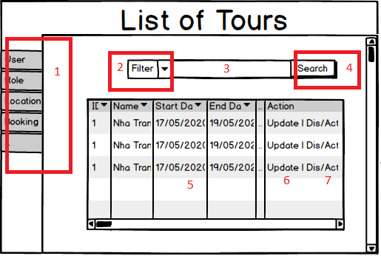

|  |  |  |  |  |  |  |
| --- | --- | --- | --- | --- | --- | --- |
| No | Name | Type | Validation | Event | Description | Status |
| 1 | Sidebar | Bar |  | Click | Click link to go equivalent page | Enable |
| 2 | Filter Search | Combo box |  | Click | Choose the search filter | Enable |
| 3 | Search input | Textbox | Not null | input | Enter input to search | Enable |
| 4 | Search button | Button |  | Click | Click to search | Enable |
| 5 | Table | Table |  | No event | Show data | Enable |
| 6 | Update button | Button |  | Click | Click to call modal to input for update | Enable |
| 7 | Dis/Active button | Button |  | Click | Click to disactive or active data | Enable |
|  |  |  |  |  |  |  |

### Modal Add:

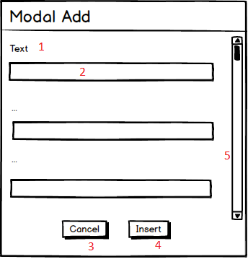

|  |  |  |  |  |  |  |
| --- | --- | --- | --- | --- | --- | --- |
| No | Name | Type | Validation | Event | Description | Status |
| 1 | Label | Label |  | No event | Show title of field input | Enable |
| 2 | Input field | Textbox | Not null | Input | Input value | Enable |
| 3 | Cancel button | Button |  | Click | Click to cancel modal | Enable |
| 4 | Insert button | Button |  | Click | Click to insert data into database | Enable |
| 5 | Scrollbar | Scrollbar |  | No event | Move to show field below | Enable |

### Modal Update:

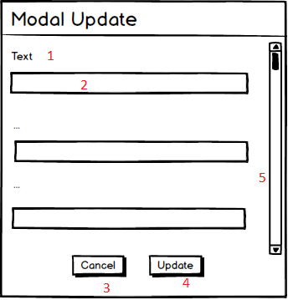

|  |  |  |  |  |  |  |
| --- | --- | --- | --- | --- | --- | --- |
| No | Name | Type | Validation | Event | Description | Status |
| 1 | Label | Label |  | No event | Show title of field input | Enable |
| 2 | Input field | Textbox | Not null | Input | Input value | Enable |
| 3 | Cancel button | Button |  | Click | Click to cancel modal | Enable |
| 4 | Update button | Button |  | Click | Click to update data to database | Enable |
| 5 | Scrollbar | Scrollbar |  | No event | Move to show field below | Enable |

### Modal Add (Location):

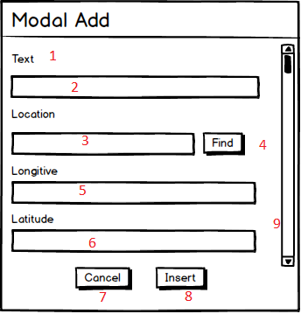

|  |  |  |  |  |  |  |
| --- | --- | --- | --- | --- | --- | --- |
| No | Name | Type | Validation | Event | Description | Status |
| 1 | Label | Label |  | No event | Show title of field input | Enable |
| 2 | Input field | Textbox | Not null | Input | Input value | Enable |
| 3 | Location input field | Input field | Not null | Input | Input location to search | Enable |
| 4 | Find button | Button |  | Click | Click to search location | Enable |
| 5 | Logitive input | Textbox |  | No event | Fill longitive of location above | Disable |
| 6 | Latitude input | Textbox |  | No event | Fill latitude of location above | Disable |
| 7 | Cancel button | button |  | click | Click to cancel modal | Enable |
| 8 | Insert button | button |  | click | Click to insert data into database | Enable |
| 9 | Scrollbar | scrollbar |  | No event | Move to show field below | Enable |

### Modal Update (Location):

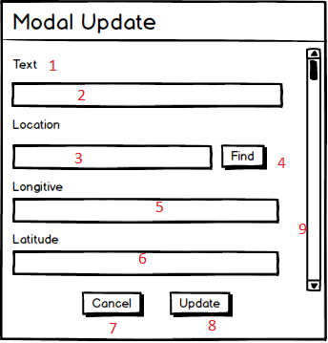

|  |  |  |  |  |  |  |
| --- | --- | --- | --- | --- | --- | --- |
| No | Name | Type | Validation | Event | Description | Status |
| 1 | Label | Label |  | No event | Show title of field input | Enable |
| 2 | Input field | Textbox | Not null | Input | Input value | Enable |
| 3 | Location input field | Input field | Not null | Input | Input location to search | Enable |
| 4 | Find button | Button |  | Click | Click to search location | Enable |
| 5 | Logitive input | Textbox |  | No event | Fill longitive of location above | Disable |
| 6 | Latitude input | Textbox |  | No event | Fill latitude of location above | Disable |
| 7 | Cancel button | button |  | click | Click to cancel modal | Enable |
| 8 | Update button | button |  | click | Click to update data to database | Enable |
| 9 | Scrollbar | scrollbar |  | No event | Move to show field below | Enable |

### Login: (Admin)

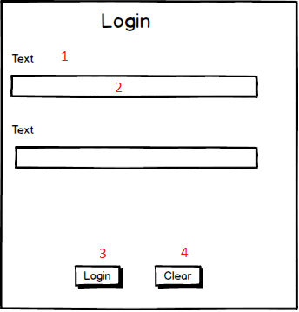

|  |  |  |  |  |  |  |
| --- | --- | --- | --- | --- | --- | --- |
| No | Name | Type | Validation | Event | Description | Status |
| 1 | Label | Label |  | No event | Show title of field input | Enable |
| 2 | Input field | Textbox | Not null | Input | Input value | Enable |
| 3 | Login button | Button |  | Click | Click to login | Enable |
| 4 | Clear button | Button |  | Click | Click to clear field content | Enable |

## **Client:**

### 1. HomePage.

Main page which a fixed nav bar and authentication model to help user easily login or change to a different page.

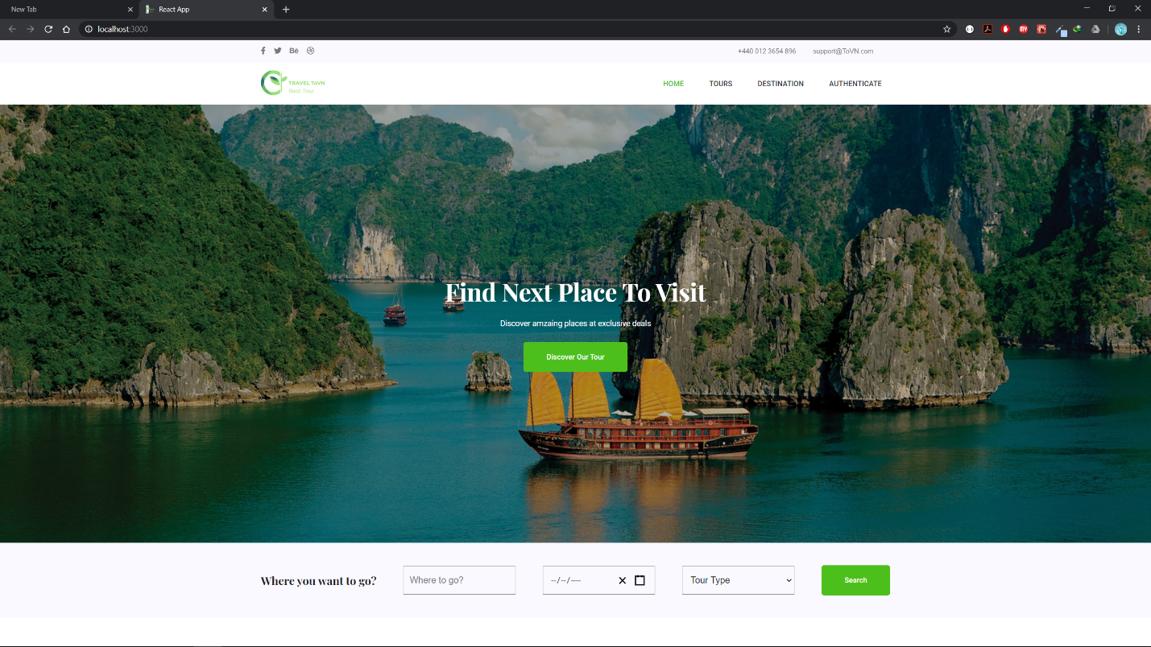

1. Authetication Model

Allow user to login with their account or login with their social media through facebook or google.

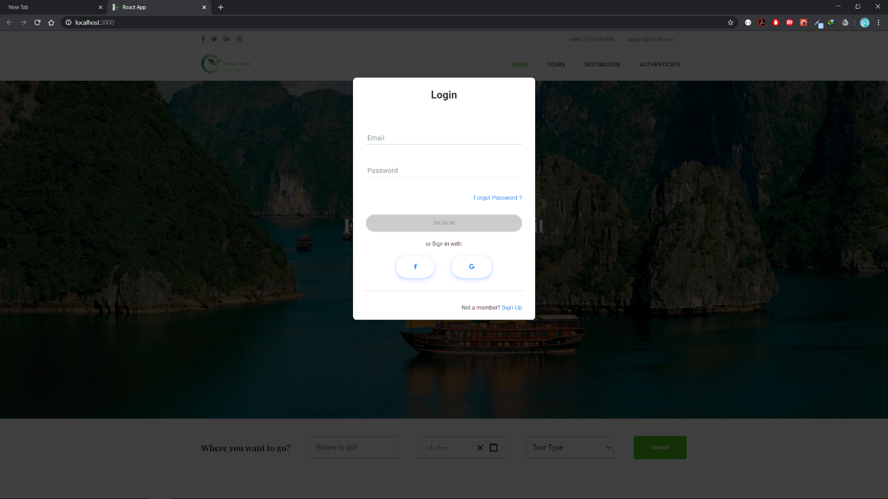

They can also choose to signup to create their own account.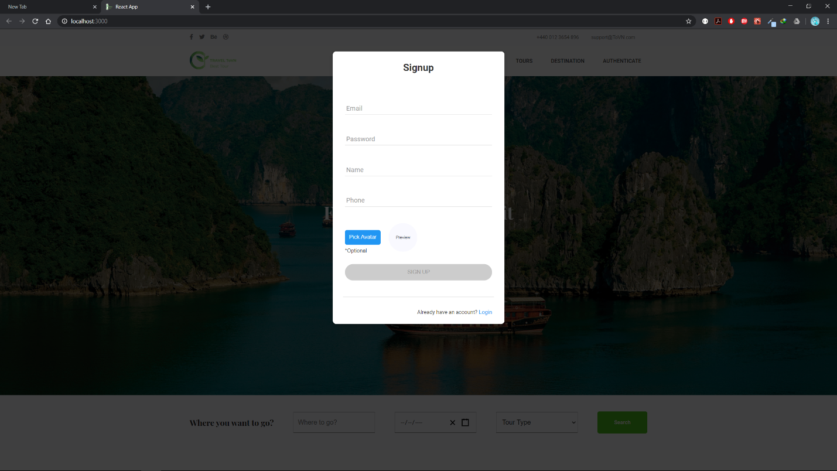

1. Search tour

User can provide the place they want to go, their starting date and tour type to search

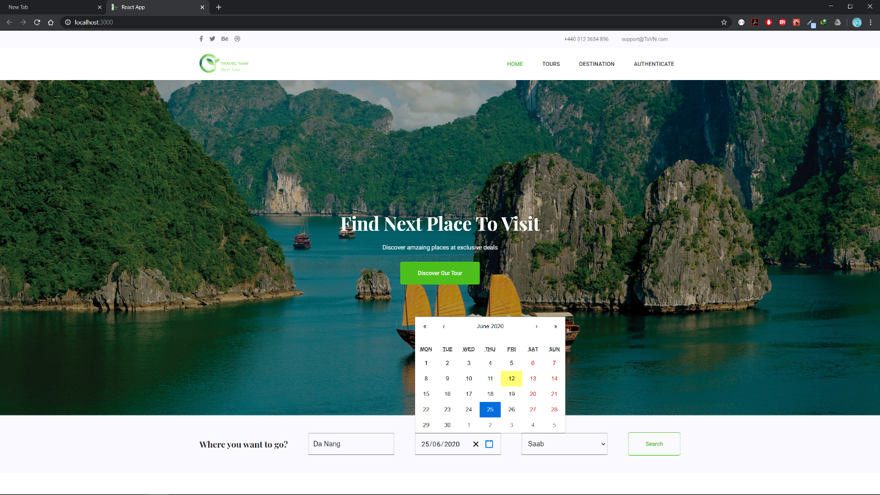

### 2. Tour

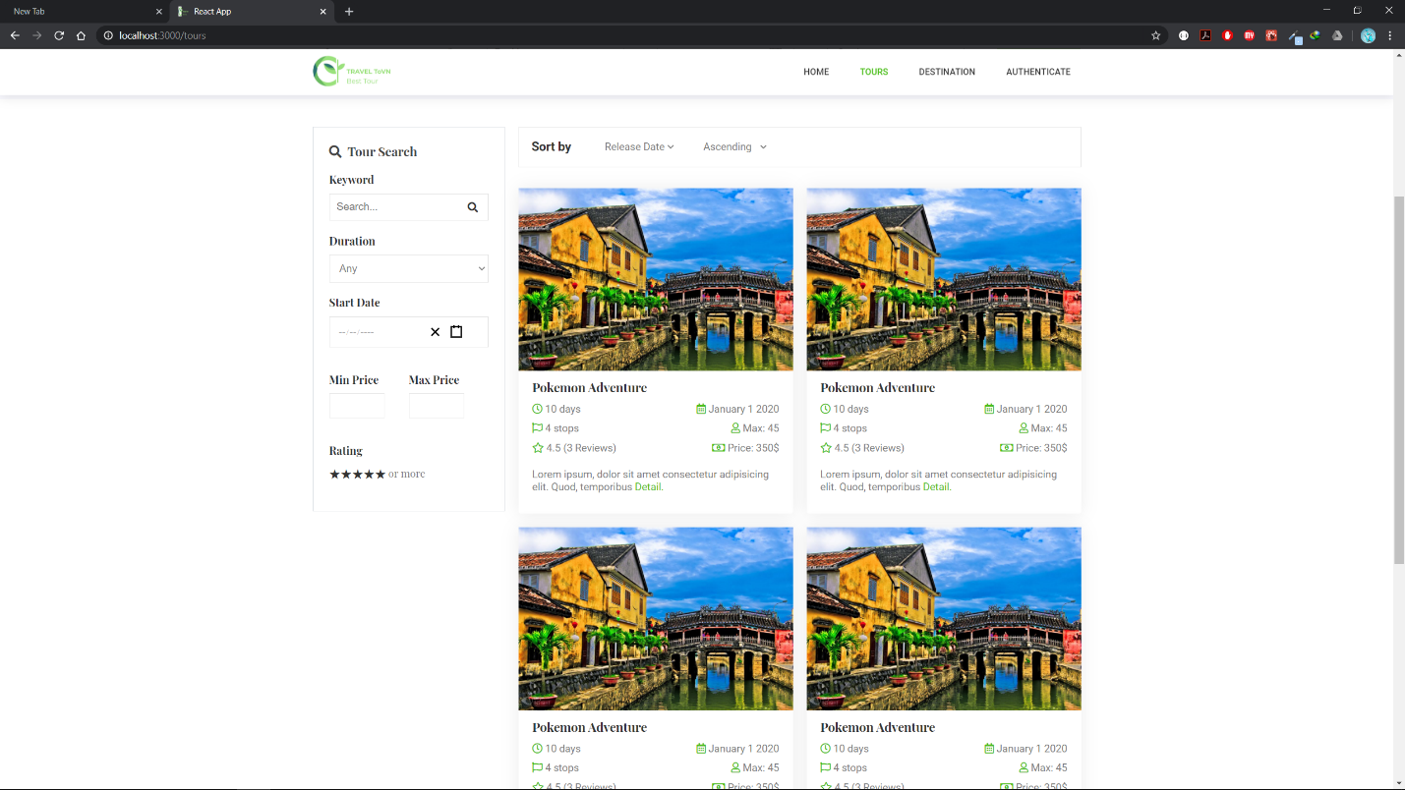

User can search, filter, sort tour according to their need. This page also provide summary info about the tour like the duration, starting date, price, rating,... For more info, user can navigate to the tour detail page

### 3. Tour Detail

Provide a much detail info about their chosen tour including the description, the tour guide, the map to help user visualize their tour schedule, and also the comment section.

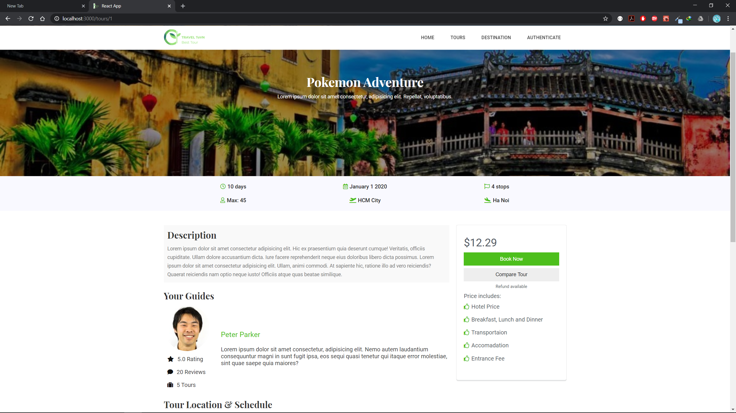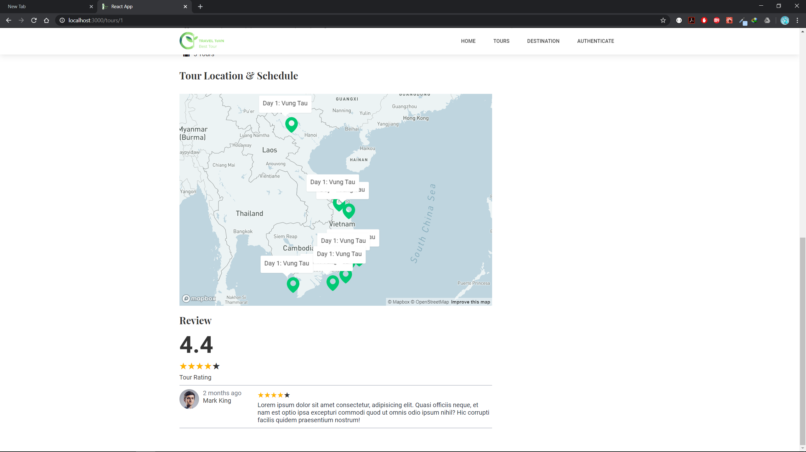

### 4. Login User

If the user login, the Authentication section will be replaced with their avatar (if provided or default the black and white avatar). User can now navigatiate to view their info, purchase history, their upcoming trip schedule or logout.

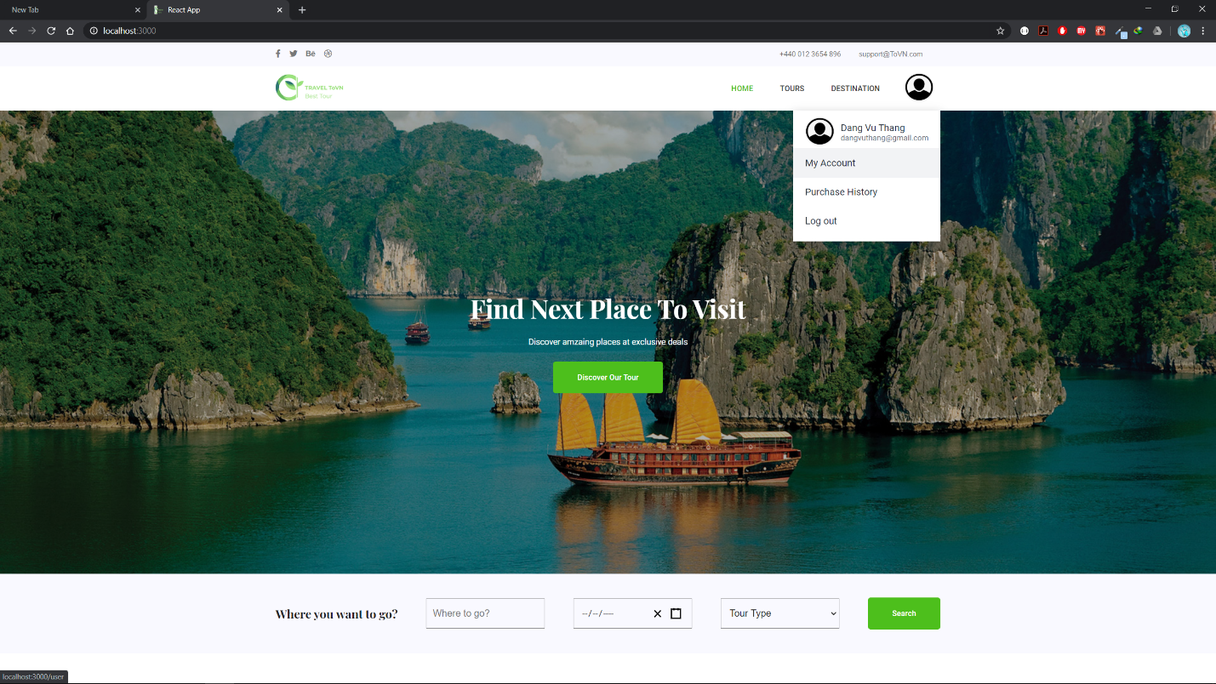

# **TASK SHEET REVIEW 3**

|  |  |  |  |  |  |  |  |
| --- | --- | --- | --- | --- | --- | --- | --- |
| **Project Ref. No.:**  **FOOD advisor** | | **Project Title:** | **Activity Plan Prepared By:** | **Date of Preparation of Activity Plan:** | | | |
| **Sr.No** | **Task** | **Actual Start Date** | **Actual Days** | **Team Mate Names** | **Status** |
| 1 | Admin Login | TRAVEL ToVN | Dang Vu Thang | 02/06/2020 | 5 | Ta Van Vu | Done |
| 2 | Tours Insert, Update, Disactive/Active | 02/06/2020 | Done |
| 3 | Locations Insert, Update, Disactive/Active | 02/06/2020 | Done |
| 4 | Images Insert, Update, Delete | 02/06/2020 | Done |
| 5 | TourImages Insert, Update, Delete | 02/06/2020 | Done |
| 6 | TourLocation Insert, Update, Delete | 02/06/2020 | Done |
| 7 | TourTypes  Insert, Update, Delete | 02/06/2020 | 5 | Tran Duc Truong Giang | Done |
| 8 | View/Search Booking | 02/06/2020 | Done |
| 9 | Roles Insert, Update, Delete | 02/06/2020 | Done |
| 10 | View/Search User | 02/06/2020 | Done |
| 11 | Disactive/Active User | 02/06/2020 | Done |
| 12 | Statistic | 02/06/2020 | 5 | Tran Duc Truong Giang, Ta Van Vu | Done |
| 13 | Client Website Design | 02/06/2020 | 5 | Dang Vu Thang | Done |
| 14 | Implement with react, and react-router-dom | 07/06/2020 | 1 | Done |
| 15 | Implement authentication with social media through firebase | TRAVEL ToVN | Dang Vu Thang | 08/06/2020 | 1 | Dang Vu Thang | Done |
| 16 | Implement json webtoken |
| 17 | Entity Model => Actual database table | 1 | Dang Vu Thang, Nguyen Huu Phuc | Done |
| 18 | Implement RESTFUL API | 02/06/2020 | NOT DONE | NOT DONE |
| 19 | Login and Logout with jwt |  |  | 02/06/2020 | DONE | DONE |

|  |  |
| --- | --- |
| **Date: 24/06/2020** | |
| Signature of Instructor:  **MR. NGO PHUOC NGUYEN** | Signature of Team Leader:  **DANG VU THANG** |